**COMP122 – Winter2017 Assigment2 _ Section 06**

**Sargis Nahapetyan: 300904358**

**Section A:**

**Question 1:**

SELECT a.COLUMN_NAME

FROM all_cons_columns a INNER JOIN all_constraints c

ON a.constraint_name = c.constraint_name

WHERE (c.table_name = 'ALIASES' AND c.constraint_type = 'P') OR

(c.table_name = 'CRIMINALS' AND c.constraint_type = 'P') OR

(c.table_name = 'CRIMES' AND c.constraint_type = 'P') OR

(c.table_name = 'CRIMINALS_DW' AND c.constraint_type = 'P') OR

(c.table_name = 'PROB_OFFICERS' AND c.constraint_type = 'P') OR

(c.table_name = 'SENTENCES' AND c.constraint_type = 'P') OR

(c.table_name = 'OFFICERS' AND c.constraint_type = 'P') OR

(c.table_name = 'CRIME_CODES' AND c.constraint_type = 'P');

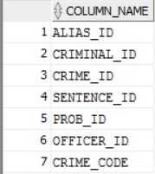

**Question 2:**

SELECT a.COLUMN_NAME , a.table_name

FROM all_cons_columns a INNER JOIN all_constraints c

ON a.constraint_name = c.constraint_name

WHERE (c.table_name = 'ALIASES' AND c.constraint_type = 'R') OR

(c.table_name = 'CRIMINALS' AND c.constraint_type = 'R') OR

(c.table_name = 'CRIMES' AND c.constraint_type = 'R') OR

(c.table_name = 'CRIMINALS_DW' AND c.constraint_type = 'R') OR

(c.table_name = 'PROB_OFFICERS' AND c.constraint_type = 'R') OR

(c.table_name = 'SENTENCES' AND c.constraint_type = 'R') OR

(c.table_name = 'OFFICERS' AND c.constraint_type = 'R') OR

(c.table_name = 'CRIME_CODES' AND c.constraint_type = 'R');

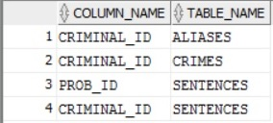

**Question 3:**

SELECT a.COLUMN_NAME, c.table_name

FROM all_cons_columns a INNER JOIN all_constraints c

ON a.constraint_name = c.constraint_name

WHERE (c.table_name = 'ALIASES' AND c.constraint_type = 'C') OR

(c.table_name = 'CRIMINALS' AND c.constraint_type = 'C') OR

(c.table_name = 'CRIMES' AND c.constraint_type = 'C') OR

(c.table_name = 'CRIMINALS_DW' AND c.constraint_type = 'C') OR

(c.table_name = 'PROB_OFFICERS' AND c.constraint_type = 'C') OR

(c.table_name = 'SENTENCES' AND c.constraint_type = 'C') OR

(c.table_name = 'OFFICERS' AND c.constraint_type = 'C') OR

(c.table_name = 'CRIME_CODES' AND c.constraint_type = 'C');

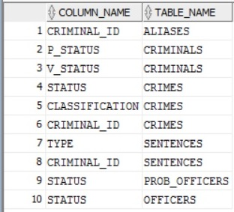

**Section B:**

**Question 1:**

SELECT CRIMINALS.CRIMINAL_ID, CRIMINALS."LAST", CRIMINALS."FIRST", CRIME_CHARGES.CRIME_CODE, CRIME_CHARGES.FINE_AMOUNT

FROM CRIME_CHARGES

INNER JOIN CRIME_CODES

ON CRIME_CODES.CRIME_CODE = CRIME_CHARGES.CRIME_CODE

INNER JOIN CRIMES

ON CRIMES.CRIME_ID = CRIME_CHARGES.CRIME_ID

INNER JOIN CRIMINALS

ON CRIMINALS.CRIMINAL_ID = CRIMES.CRIMINAL_ID

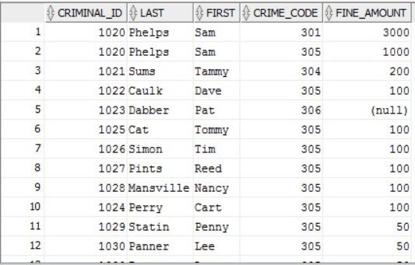

**Question 2:**

SELECT CRIMES.STATUS, APPEALS.STATUS AS APPEAL_STATUS, CRIMINALS.CRIMINAL_ID, CRIMINALS."LAST", CRIMINALS."FIRST", CRIMES.CLASSIFICATION, CRIMES.DATE_CHARGED, APPEALS.FILING_DATE

FROM CRIMES

LEFT JOIN CRIMINALS

ON CRIMINALS.CRIMINAL_ID = CRIMES.CRIMINAL_ID

FULL JOIN APPEALS

ON CRIMES.CRIME_ID = APPEALS.CRIME_ID

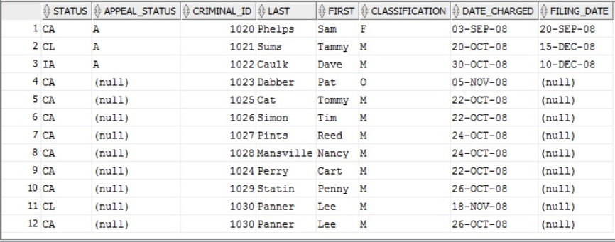

**Question 3:**

SELECT CRIMINALS."LAST", CRIMINALS."FIRST", CRIMINALS.CRIMINAL_ID, CRIMES.CLASSIFICATION, CRIMES.DATE_CHARGED, CRIME_CHARGES.CRIME_CODE, CRIME_CHARGES.FINE_AMOUNT

FROM CRIMES

INNER JOIN CRIMINALS

ON CRIMINALS.CRIMINAL_ID = CRIMES.CRIMINAL_ID

INNER JOIN CRIME_CHARGES

ON CRIMES.CRIME_ID = CRIME_CHARGES.CRIME_ID

WHERE CRIMES.CLASSIFICATION = 'O'



**Question 4:**

SELECT CRIMINALS.CRIMINAL_ID, CRIMINALS."LAST", CRIMINALS."FIRST", CRIMINALS.V_STATUS, CRIMINALS.P_STATUS, ALIASES.ALIAS

FROM CRIMINALS

LEFT JOIN ALIASES

ON CRIMINALS.CRIMINAL_ID = ALIASES.CRIMINAL_ID

ORDER BY CRIMINALS."LAST"

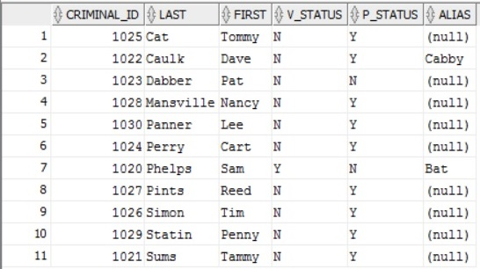

**Question 5:**

SELECT CRIMINALS.CRIMINAL_ID, SENTENCES.TYPE, CRIMINALS."LAST", CRIMINALS."FIRST", SENTENCES.START_DATE, SENTENCES.END_DATE, SENTENCES.END_DATE - SENTENCES.START_DATE AS PROB_LENGTH,

CASE

WHEN SENTENCES.END_DATE - SENTENCES.START_DATE < 81

THEN 'Weekly'

WHEN SENTENCES.END_DATE - SENTENCES.START_DATE < 160

THEN 'Every 2 Weeks'

WHEN SENTENCES.END_DATE - SENTENCES.START_DATE < 500

THEN 'Monthly'

END AS PROB_PERIOD

FROM CRIMINALS

INNER JOIN SENTENCES

ON CRIMINALS.CRIMINAL_ID = SENTENCES.CRIMINAL_ID

WHERE SENTENCES.TYPE = 'P'

ORDER BY CRIMINALS."LAST",

SENTENCES.START_DATE

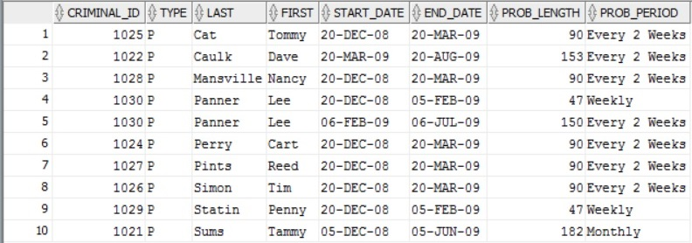

**Section C:**

**Question 1:**

SELECT BOOKS.TITLE, PUBLISHER.NAME, PUBLISHER.PHONE

FROM PUBLISHER

INNER JOIN BOOKS

ON PUBLISHER.PUBID = BOOKS.PUBID

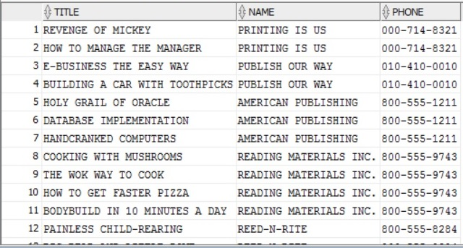

**Question 3:**

SELECT CUSTOMERS.CUSTOMER#, CUSTOMERS.LASTNAME, CUSTOMERS.FIRSTNAME, CUSTOMERS.STATE, BOOKS.CATEGORY

FROM BOOKS

INNER JOIN ORDERITEMS

ON BOOKS.ISBN = ORDERITEMS.ISBN

INNER JOIN ORDERS

ON ORDERS.ORDER# = ORDERITEMS.ORDER#

INNER JOIN CUSTOMERS

ON CUSTOMERS.CUSTOMER# = ORDERS.CUSTOMER#

WHERE CUSTOMERS.STATE = 'FL'

AND BOOKS.CATEGORY = 'COMPUTER'

